**Creating Microservices for account and loan**

**AccountController.java:**

package com.cognizant.account.controller;

import org.springframework.web.bind.annotation.GetMapping;

import org.springframework.web.bind.annotation.PathVariable;

import org.springframework.web.bind.annotation.RestController;

import org.springframework.web.bind.annotation.RequestMapping;

import java.util.Map;

*@RestController*

*@RequestMapping*("/accounts")

public class AccountController {

*@GetMapping*("/{number}")

public Map<String,Object> getAccount(*@PathVariable* String number){

return Map.*of*(

"number" , number,

"type" , "Savings",

"balance" , 23456

);

}

}

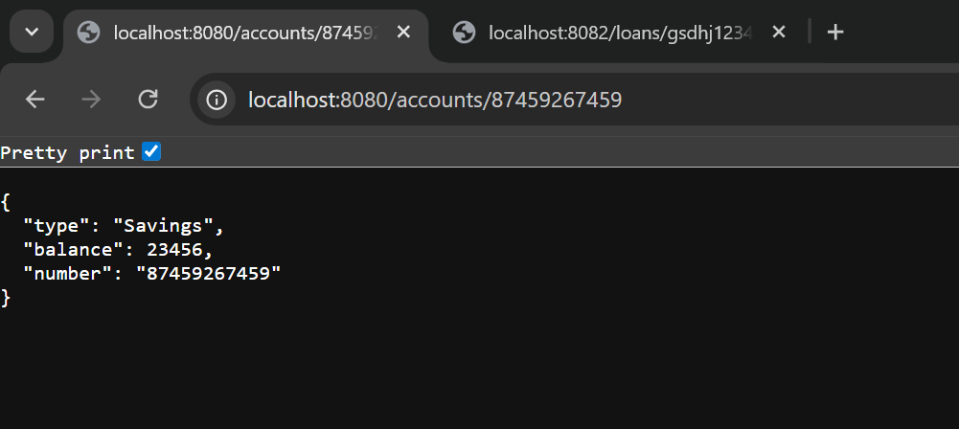

**LoanController.java:**

package com.cognizant.loan.controller;

import org.springframework.web.bind.annotation.GetMapping;

import org.springframework.web.bind.annotation.RequestMapping;

import org.springframework.web.bind.annotation.RestController;

import org.springframework.web.bind.annotation.PathVariable;

import java.util.Map;

*@RestController*

*@RequestMapping*("/loans")

public class LoanController {

*@GetMapping*("/{id}")

public Map<String , Object> getLoan(*@PathVariable* String id){

return Map.*of*(

"number", id,

"type", "car",

"loan", "400000",

"emi", "3258",

"tenure","18"

);

}

}

